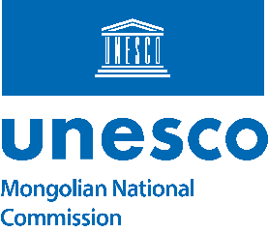 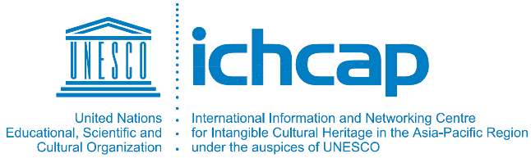

Conference on Exploring and Safeguarding the Shared Intangible Cultural Heritages

in East Asia

Date: Friday, 10 September 2021, 13:00– 16:00 PM (Ulaanbaatar, GMT +8)

Interpretations: English, Korean & Japanese

|  |  |
| --- | --- |
| Draft Agenda | |
| 12:50 – 13:00 | Moderator, participants, and viewers will join through Zoom link  Shared Intangible Cultural Heritage (ICH) introduction video will be presented |
| 13:00 – 13:20 | Opening remarks by:   * Prof. Shahbaz Khan, Director of UNESCO Beijing Cluster Office * Mr. Keum Gi Hyung, Director-General, ICHCAP * Mr. Boldsaikhan Sambuu, Secretary General of Mongolian National Commission for UNESCO |
| 13:20 – 13:30 | Moderator: Dr. Sangmee Bak, Professor at Hankuk University of Foreign Studies & Member of Cultural Heritage Committee of the Republic of Korea   * Introduction of the Shared Intangible Cultural Heritage (ICH) * Introduction of the experts |
| 13:30 – 13:40 | Speaker 1: Dr. Urtnasan Norov, President of Foundation for the Protection of Natural and Cultural Heritage of Mongolia- **Perspective of Mongolia on multinational ICH nominations”** |
| 13:40 – 13:50 | Speaker 2: Ms. Tsolmon Tserendorj: Policy Coordination Specialist for ICH at the Cultural Heritage Department of Ministry of Culture of Mongolia- “**Falconry, a living human heritage in Mongolia”** |
| 13:50 – 14:00 | Speaker 3: Dr. Park Weonmo, Director of Office of Cooperation and Networking, International Information and Networking Centre for Intangible Cultural Heritage in the Asia-Pacific Region under the auspices of UNESCO (ICHCAP)- **“International Cooperation through Tugging Rituals and Games”** |
| 14:00 – 14:10 | Speaker 4: Dr. Park Hyugbin, Director of Research Division of Artistic Heritage, National Research Institute of Cultural Heritage of Republic of Korea- **“Joint Inscription on UNESCO list of Ssireum/Ssirum (Traditional Korean Wrestling) in ROK and DPRK** |
| 14:10 – 14:20 | Speaker 5: Dr. Jihae Hwang, Senior Researcher, National Research Institute of Cultural Heritage of Republic of Korea- “**Falconry, a living human heritage in Korea”** |
| 14:20 – 14:30 | Break |
| 14:30 – 14:40 | Speaker 6: Dr. Prof. Gejin Chao, Senior Research Fellow & Academian Member of Chinese Academy of Social Sciences- **China-Mongolia Joint Actions for Safeguarding of “Urtiin Duu, traditional folk long song”: Retrospect and Reflection** |
| 14:40 – 14:50 | Speaker 7: Dr. Bamo Qubumo, Senior Research Fellow & Director of Oral Traditions Research Center, Institute of Ethnic Literature, Chinese Academy of Social Sciences : *Title to be noticed* |
| 14:50 – 15:00 | Speaker 8: Dr. Kubota Hiromichi, Head of Intangible Folk Cultural Properties Section, Department of Intangible Cultural Heritage, National Research Institute for Cultural Properties of Japan- **“Diversity in intangible cultural heritage as seen through lion dances”** |
| 15:00 – 15:10 | Speaker 9: Dr. Maehara Megumi, Head of Intangible Cultural Properties Section, Department of Intangible Cultural Heritage of Japan- **“A diversity-focused approach to musical instruments”** |
| 15:10 – 15:40 | Q&A |
| 15:40 – 16:00 | Closing remarks by:   * Mr. Boldsaikhan Sambuu, Secretary General of Mongolian National Commission for UNESCO * Dr. Park Weonmo, Director of Office of Cooperation and Networking, International Information and Networking Centre for Intangible Cultural Heritage in the Asia-Pacific Region under the auspices of UNESCO (ICHCAP)- * Himalchuli Gurung, Programme Specialist or Culture, UNESCO Beijing Cluster Office |